Day 6 Assignment
Set 1 Retail Sales Reporting
Topic: GROUP BY, HAVING, Joins and MongoDB Aggregation Basics
1. Business Scenario
The retail sales team requires daily and monthly sales reports to analyse business performance. The data is maintained in four tables: Orders, Order_Items, Customers and Products.
SQL queries are used to retrieve sales information, identify top-selling products, analyse customer purchases and generate useful business reports.
2. Objectives
- Generate sales reports using GROUP BY and HAVING.
- Retrieve related information using different types of JOIN operations.
- Apply string, date and mathematical functions.
- Understand NULL behaviour in aggregate functions.
- Document the expected result sets.
- Use MongoDB aggregation pipelines to generate equivalent reports.
3. Database Details
Database Name: RetailSalesDB
Tables:
- Customers
- Orders
- Order_Items
- Products

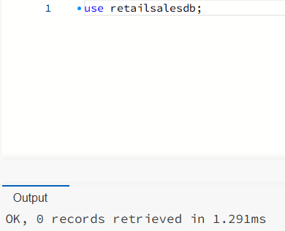
First, execute this database creation script:

Question 1: SQL Queries for Retail Sales Reporting
Objective:
To generate eight different sales reports using SQL aggregate functions, GROUP BY, HAVING, and JOIN operations.
1.1 Top-5 Products by Revenue
Description:
This query identifies the five products that generate the highest revenue. Revenue is calculated by multiplying quantity by unit price.
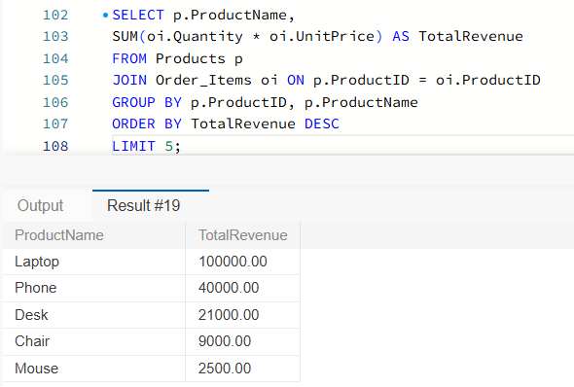
SQL Concepts: SUM(), GROUP BY, ORDER BY, TOP.

1.2 Month-wise Sales
Description:
This query calculates total sales for each month. It helps the retail team compare monthly business performance.
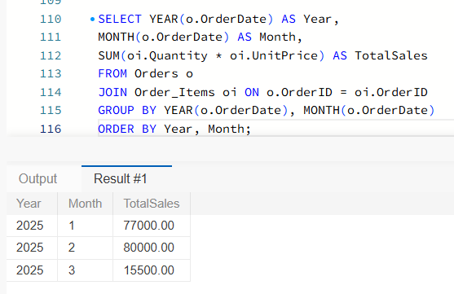
SQL Concepts: SUM(), GROUP BY, MONTH(), YEAR().

1.3 Customers with More Than Three Orders
Description:
This query identifies customers who have placed more than three orders. The HAVING clause filters grouped customer records.
SQL Concepts: COUNT(), GROUP BY, HAVING, JOIN.
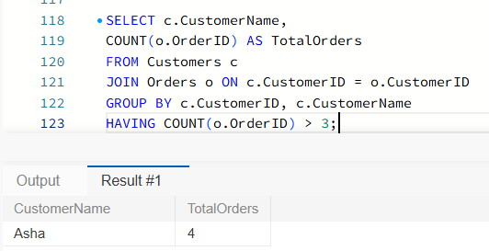

1.4 Average Basket Value per City
Description:
This query calculates the average order value for each city. It helps the retail team understand customer spending patterns across different cities.
SQL Concepts: AVG(), SUM(), GROUP BY, JOIN.
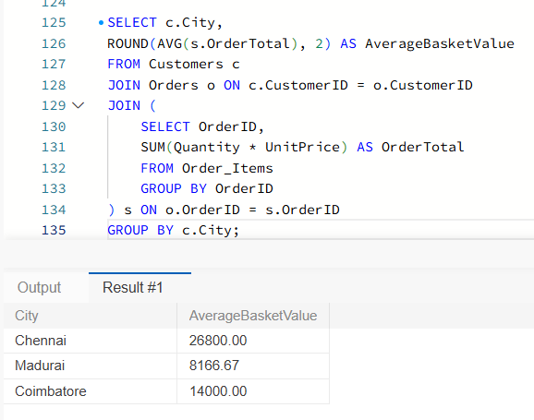
1.5 Orders Without Payment
Description:
This query identifies orders that do not have a corresponding payment record by using LEFT JOIN.
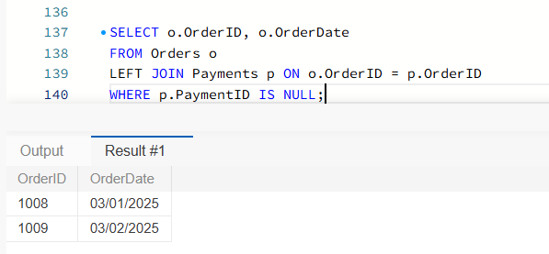
SQL Concepts: LEFT JOIN, IS NULL.

1.6 Customers with No Orders
Description:
This query identifies customers who have not placed any orders.
SQL Concepts: LEFT JOIN, IS NULL.
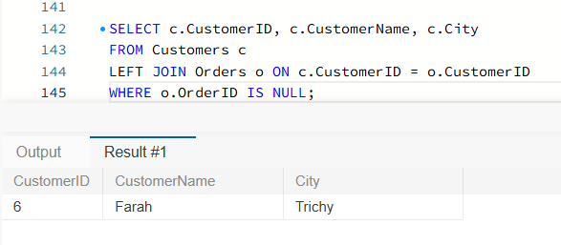
1.7 Product-Category Revenue Share
Description:
This query calculates the revenue generated by each product category and its percentage contribution to total revenue.
SQL Concepts: SUM(), GROUP BY, mathematical calculations.
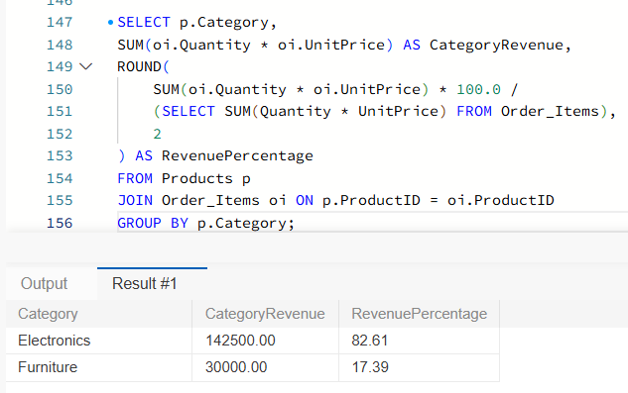

1.8 Day with the Highest Sales
Description:
This query identifies the date on which the highest sales were recorded.
SQL Concepts: SUM(), GROUP BY, ORDER BY, TOP.
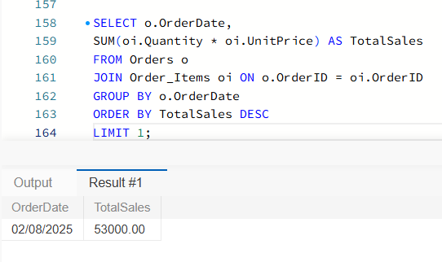
Question 2: Using String, Date and Mathematical Functions
Objective:
To use SQL built-in functions to generate customer-friendly output columns for retail sales reports.
Functions Used:
- UPPER() – Converts text into uppercase letters.
- CONCAT() – Combines two or more strings.
- DATEDIFF() – Calculates the difference between two dates.
- FORMAT() – Displays dates in a readable format.
- ROUND() – Rounds numeric values to the specified decimal places.
Description:
These functions improve the readability and presentation of retail sales information. They help generate understandable customer names, formatted dates and rounded sales values.
Expected Result:
The output contains customer name in uppercase, city, formatted order date, number of days since the order, and order amount.
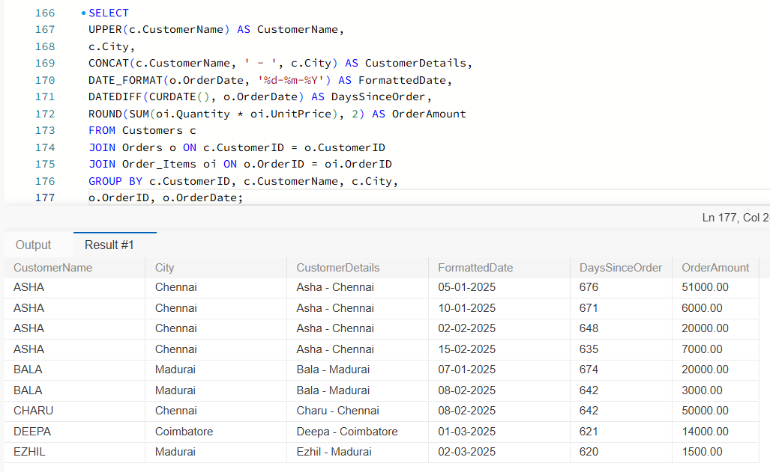
Question 3: Understanding NULL Behaviour in Aggregate Functions
Objective:
To understand how COUNT(*) , COUNT(column) and AVG(column) handle NULL values in SQL Server.
1. COUNT(*)
COUNT(*) counts all rows in a table, including rows containing NULL values.
2. COUNT(column)
COUNT(column) counts only non-NULL values in the specified column.
3. AVG(column)
AVG(column) calculates the average of non-NULL numeric values. NULL values are ignored.
Example Using Retail Sales Data
The Payments table contains seven records. One record has a NULL PaymentAmount.
Therefore:
- COUNT(*) returns 7 because it counts all rows.
- COUNT(PaymentAmount) returns 6 because one value is NULL.
- AVG(PaymentAmount) calculates the average using only the six non-NULL payment amounts.
Conclusion:
COUNT(*) counts every row, whereas COUNT(column) and AVG(column) ignore NULL values. Understanding NULL behaviour helps generate accurate sales and payment reports.
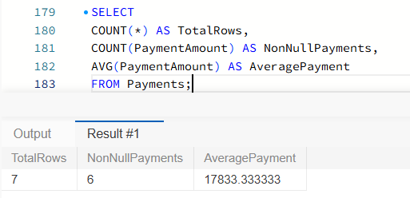
Question 4: Documentation of Expected Result Sets
Objective:
To document the expected output of all eight SQL queries created for the Retail Sales Reporting scenario.
Expected Results
Query | Report | Expected Output
1.1 | Top-5 Products | Five products arranged by highest revenue
1.2 | Month-wise Sales | Total sales grouped by year and month
1.3 | Customers with More Than Three Orders | Customers having more than three orders
1.4 | Average Basket Value per City | Average order amount for each city
1.5 | Orders Without Payment | Orders without matching payment records
1.6 | Customers with No Orders | Customers who have not placed any orders
1.7 | Category Revenue Share | Category-wise revenue and percentage
1.8 | Highest Sales Day | Date with the highest total sales
Conclusion
The eight SQL queries demonstrate the practical use of GROUP BY, HAVING, aggregate functions, and different JOIN operations in retail sales reporting.
These queries help the retail sales team analyse product performance, customer purchasing behaviour, monthly revenue and payment information. The expected result sets provide a clear understanding of the output generated by each query.

Question 5: MongoDB Aggregation Pipelines
Objective:
To implement MongoDB aggregation pipelines using $match, $group and $sort stages to generate retail sales reports.
Tool Used: MongoDB Community Server 8.0 and MongoDB Compass.
Introduction
MongoDB Aggregation is used to process documents and perform calculations on data stored in collections. It helps generate reports by filtering, grouping and sorting records.
Aggregation Stages
- $match – Filters documents based on specified conditions.
- $group – Groups documents and performs calculations such as SUM and AVG.
- $sort – Arranges the output in ascending or descending order.
Reports to be Generated
- Month-wise Sales Report
- Top Products by Revenue
- Average Basket Value per City
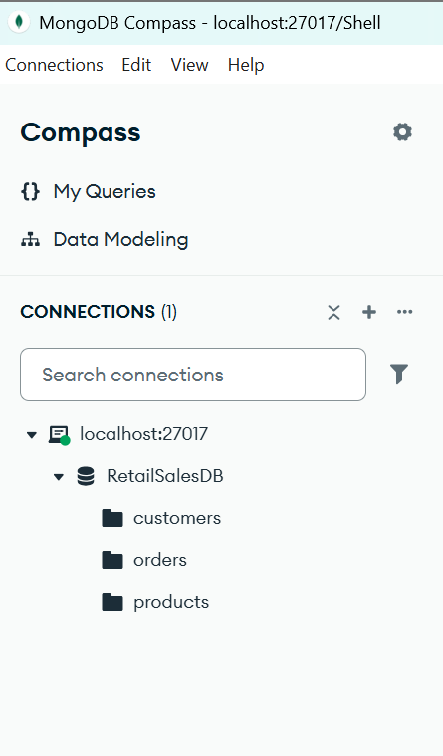

5.1 Inserting and Verifying Sample Data
Sample retail data was inserted into the MongoDB database RetailSalesDB using the insertMany() method.
Customers Collection:
Six customer records were inserted with customer ID, customer name and city.
Products Collection:
Five product records were inserted with product ID, product name, category and unit price.
Data Verification:
The find() method was used to retrieve and verify the inserted customer and product documents.
Customer and Product Data Insertion
Capture the MongoDB Shell showing:
- customers.insertMany()
- products.insertMany()
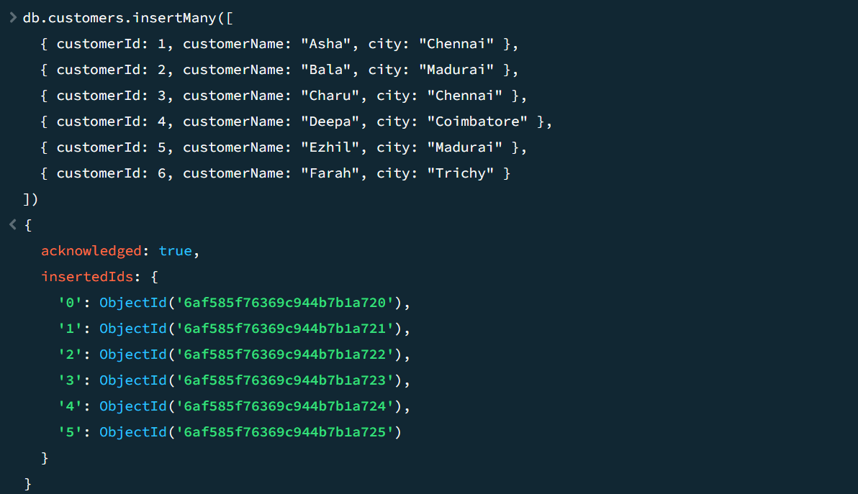
- Successful insertion messages.
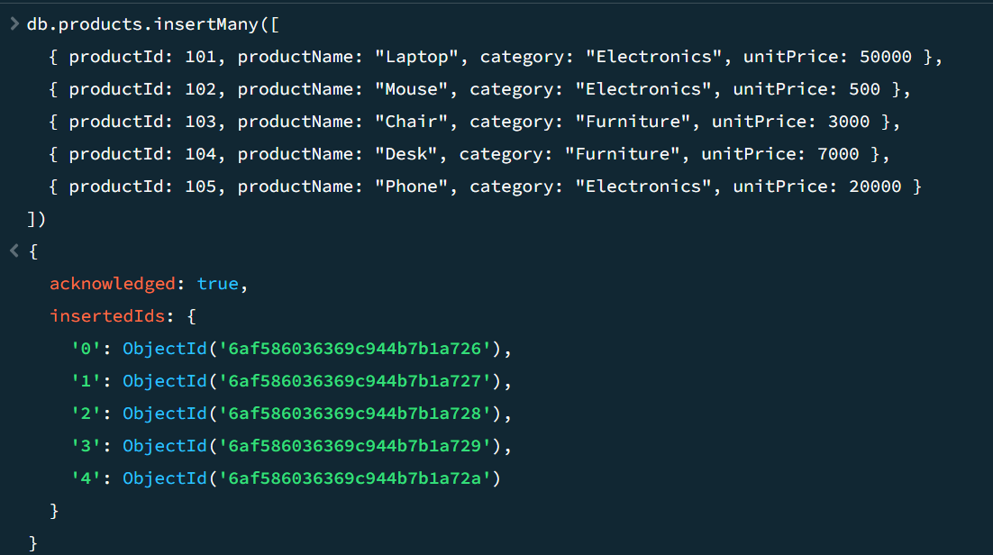
Data Verification
Capture:
- db.products.find()
- db.customers.find()
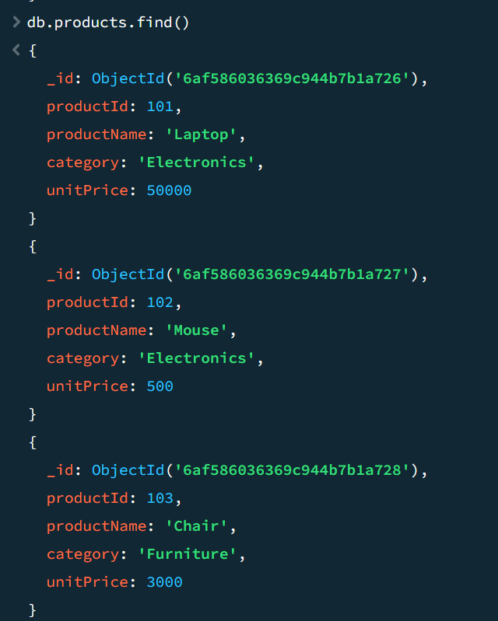
- Displayed documents.
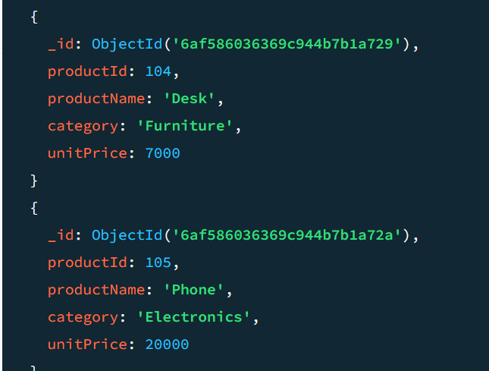
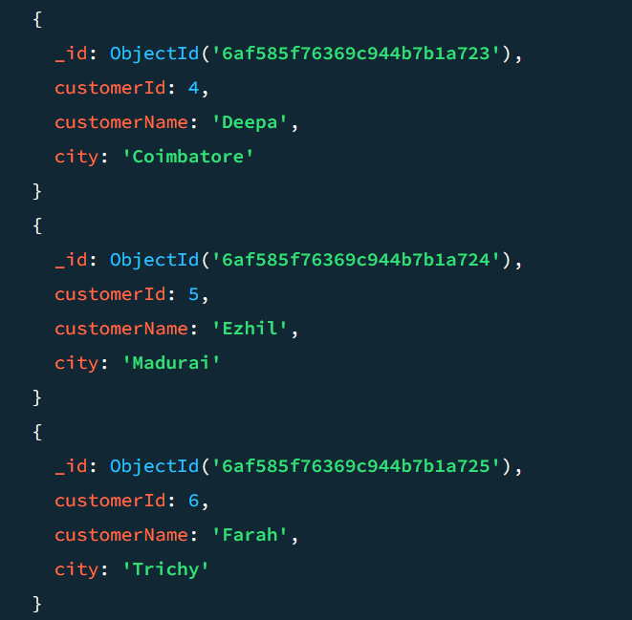
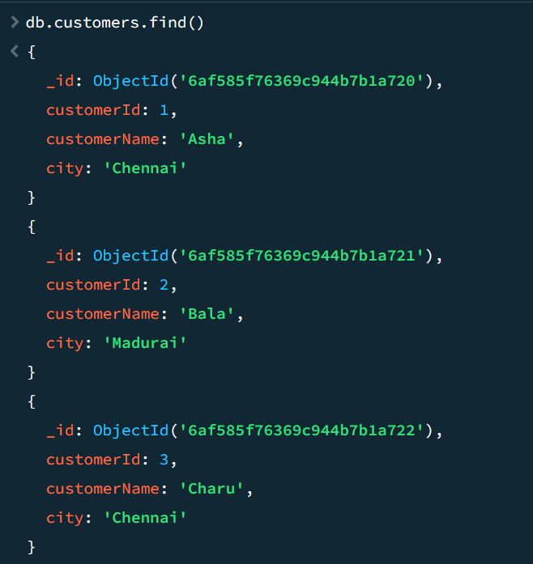
5.2 Inserting Order Documents
The orders collection stores retail transaction details, including order ID, customer ID, city, order date and purchased product information.
The insertMany() method is used to insert multiple order documents into the MongoDB collection.
Each order contains product details such as product ID, product name, category, quantity and unit price.
Insert Many
db.orders.insertMany([
{
orderId: 1001, customerId: 1, city: "Chennai",
orderDate: ISODate("2025-01-05"),
items: [
{ productId: 101, productName: "Laptop", category: "Electronics", quantity: 1, unitPrice: 50000 },
{ productId: 102, productName: "Mouse", category: "Electronics", quantity: 2, unitPrice: 500 }
]
},
{
orderId: 1002, customerId: 1, city: "Chennai",
orderDate: ISODate("2025-01-10"),
items: [
{ productId: 103, productName: "Chair", category: "Furniture", quantity: 2, unitPrice: 3000 }
]
},
{
orderId: 1003, customerId: 1, city: "Chennai",
orderDate: ISODate("2025-02-02"),
items: [
{ productId: 105, productName: "Phone", category: "Electronics", quantity: 1, unitPrice: 20000 }
]
},
{
orderId: 1004, customerId: 1, city: "Chennai",
orderDate: ISODate("2025-02-15"),
items: [
{ productId: 104, productName: "Desk", category: "Furniture", quantity: 1, unitPrice: 7000 }
]
},
{
orderId: 1005, customerId: 2, city: "Madurai",
orderDate: ISODate("2025-01-07"),
items: [
{ productId: 105, productName: "Phone", category: "Electronics", quantity: 1, unitPrice: 20000 }
]
},
{
orderId: 1006, customerId: 2, city: "Madurai",
orderDate: ISODate("2025-02-08"),
items: [
{ productId: 103, productName: "Chair", category: "Furniture", quantity: 1, unitPrice: 3000 }
]
},
{
orderId: 1007, customerId: 3, city: "Chennai",
orderDate: ISODate("2025-02-08"),
items: [
{ productId: 101, productName: "Laptop", category: "Electronics", quantity: 1, unitPrice: 50000 }
]
},
{
orderId: 1008, customerId: 4, city: "Coimbatore",
orderDate: ISODate("2025-03-01"),
items: [
{ productId: 104, productName: "Desk", category: "Furniture", quantity: 2, unitPrice: 7000 }
]
},
{
orderId: 1009, customerId: 5, city: "Madurai",
orderDate: ISODate("2025-03-02"),
items: [
{ productId: 102, productName: "Mouse", category: "Electronics", quantity: 3, unitPrice: 500 }
]
}
])
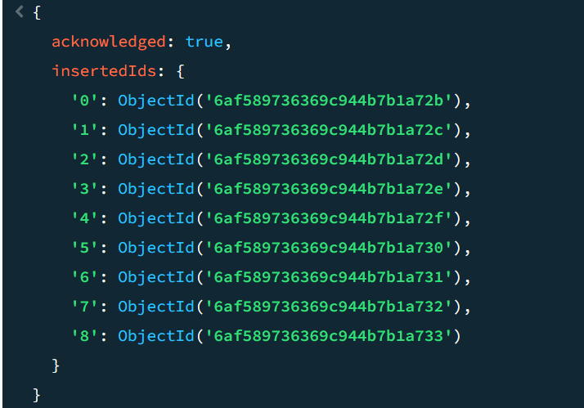

Verify the orders collection
db.orders.find()
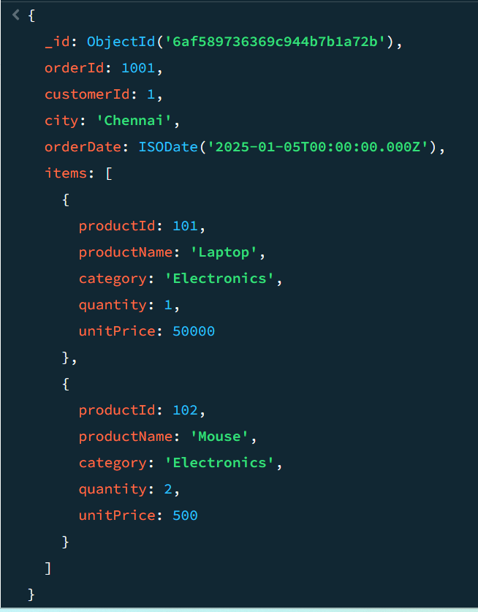
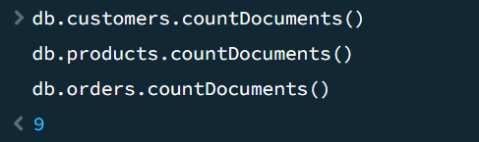

5.3 Aggregation Pipeline 1 – Month-wise Sales Report
Objective:
To calculate the total sales for each month using MongoDB aggregation.
Aggregation stages used:
- $match – Filters orders within the required date range.
- $unwind – Separates the items array into individual documents.
- $group – Groups sales by year and month and calculates total revenue.
- $sort – Sorts the results by year and month.
MongoDB Query:
db.orders.aggregate([
{
$match: {
orderDate: {
$gte: ISODate("2025-01-01"),
$lt: ISODate("2025-04-01")
}
}
},
{
$unwind: "$items"
},
{
$group: {
_id: {
year: { $year: "$orderDate" },
month: { $month: "$orderDate" }
},
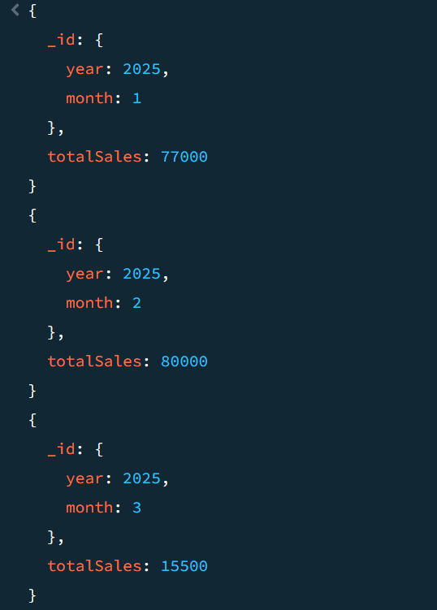
totalSales: {
$sum: {
$multiply: [
"$items.quantity",
"$items.unitPrice"
]
}
}
}
},
{
$sort: {
"_id.year": 1,
"_id.month": 1
}
}
])

Conclusion:
The aggregation pipeline successfully calculates month-wise sales. February 2025 has the highest sales of ₹80,000.

